- INTRODUCTION
TITLE: Smart Expense Categorization for Mobile Banking Apps

This Software Requirements Specification (SRS) describes the requirements for the “Smart Expense Categorization for Mobile Banking Apps” system.​
The document defines system objectives, major features, and constraints to guide development and ensure a secure, scalable, and user-friendly solution for automatic expense tracking within a mobile banking environment.​
The goal of the system is to automatically categorize user transactions, provide insightful spending analytics, and help users manage budgets more effectively while maintaining strict security and compliance standards.​
The target users include individual banking customers who want better visibility over their spending and financial institutions that wish to enhance their mobile banking offerings.​
The scope of this SRS covers functional requirements such as authentication, automatic categorization, budgeting, and reporting, as well as non-functional requirements related to performance, usability, security, reliability, scalability, and maintainability.​
The document also outlines project constraints such as the use of the MERN stack, AI tools, and cloud technologies in accordance with industry security regulations.​

1 Chosen Process Model: Scrum (Agile Development Model)
For the development of the Smart Expense Categorization for Mobile Banking Apps, the Scrum Agile Model is selected as the most suitable software engineering process model. Scrum, an iterative and incremental approach, allows for rapid development, flexibility, and continuous improvements—crucial elements for AI-powered financial applications.

1.2 Justification for Selecting Scrum
1.2.1 Iterative and Incremental Development
- The project involves AI-based transaction categorization, which requires continuous training and refinement.
- Scrum’s short sprints (2-4 weeks) allow for incremental releases, ensuring frequent improvements to AI accuracy and security.
- Flexibility in Changing Requirements
- Banking applications require frequent updates due to evolving financial regulations (GDPR, PCI-DSS).
- Agile enables quick adaptation to new security protocols, user feedback, and compliance needs.

- 1.2.3 Faster Time-to-Market with MVP Approach
- Initial sprints deliver a Minimum Viable Product (MVP) with core functionalities such as:
- AI-powered expense categorization
- Secure authentication
- Spending insights dashboard
- Later sprints introduce advanced features like fraud detection, smart budgeting, and custom user categorization rules.

- 1.2.4 Continuous AI Model Refinement & User Feedback
- AI-based transaction classification requires real-world data to enhance accuracy.
- Scrum allows frequent user testing & feedback loops, improving the system’s predictive capabilities.
- 1.2.5 Strong Focus on Security & Compliance
- Each sprint can include security assessments to ensure compliance with GDPR, PCI-DSS, and AES-256 encryption.

Process Model | Advantages | Disadvantages
Waterfall Model | Structured, well-documented | Inflexible; difficult to accommodate evolving requirements
V-Model | Strong validation and testing phases | Lacks iterative improvements; not ideal for AI-driven applications
Spiral Model | Risk analysis and iterative approach | Complex and costly for mobile banking solutions
RAD Model | Rapid prototyping | Lacks focus on security and regulatory compliance
Scrum (Agile) | Highly adaptable, iterative, supports quick enhancements | Requires close team collaboration and frequent stakeholder involvement.

2.2 Why Scrum is the Best Choice
- Unlike Waterfall, Scrum allows changes in mid-development.
- Compared to V-Model, Scrum enables continuous AI improvements rather than a fixed verification phase.
- Spiral Model is too resource-intensive for this project’s timeline.
- RAD (Rapid Application Development) focuses on quick prototyping but lacks a security-focused iterative approach.
- Scrum ensures regular updates, feedback incorporation, and compliance-focused development.

2. SCOPES & FEATURES
This section provides a high-level overview of what the system will do and the main features it will provide to end users.​
It focuses on three primary scopes: transaction categorization, budgeting and alerts, and spending insights and security.​
2.1 Scope 1 – Automatic Expense Categorization
The system will automatically classify user transactions into categories such as food, transport, shopping, and bills based on merchant information, transaction amount, and historical data.​
Machine learning models will continuously learn from user corrections to improve categorization accuracy over time, giving users more relevant and consistent expense grouping.​
Users will be able to review and manually adjust categories for any transaction to maintain control over how their expenses are organized.​
These corrections will be fed back to the model, leading to personalized categorization behavior that adapts to individual spending habits.​

2.2 Scope 2 – Budget Tracking & Alerts
The system will allow users to set monthly spending limits for each expense category, such as a fixed budget for groceries or entertainment.​
When spending in a category approach or exceeds a predefined threshold (for example, 80% of the budget), the system will send notifications through the app.​
Based on past spending patterns, the system will provide budget recommendations to help users plan realistic limits and avoid overspending in future months.​
These recommendations will support better financial discipline and encourage users to stay within their planned budgets.​
2.3 Scope 3 – Spending Insights, Reports & Security
The system will generate visual insights such as charts and graphs that show spending trends over time, broken down by category and time preriod.
Users will be able to export their spending reports in formats like PDF or CSV for external review or personal record-keeping.​
To protect sensitive financial information, the system will use strong encryption for transaction data and comply with standards such as PCI-DSS and GDPR.​
Audit logs and multi-factor authentication will further enhance security and accountability for all user activities within the app

3.USE CASE DIAGRAM
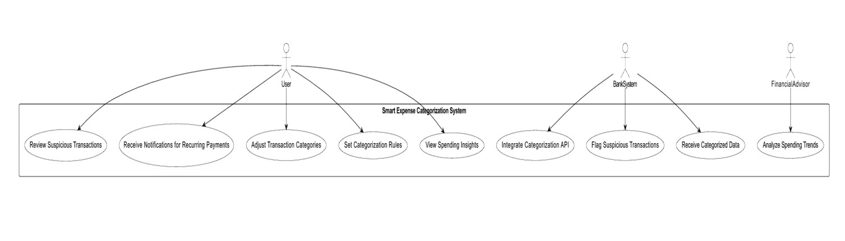

Fig 01: Use Case Diagram
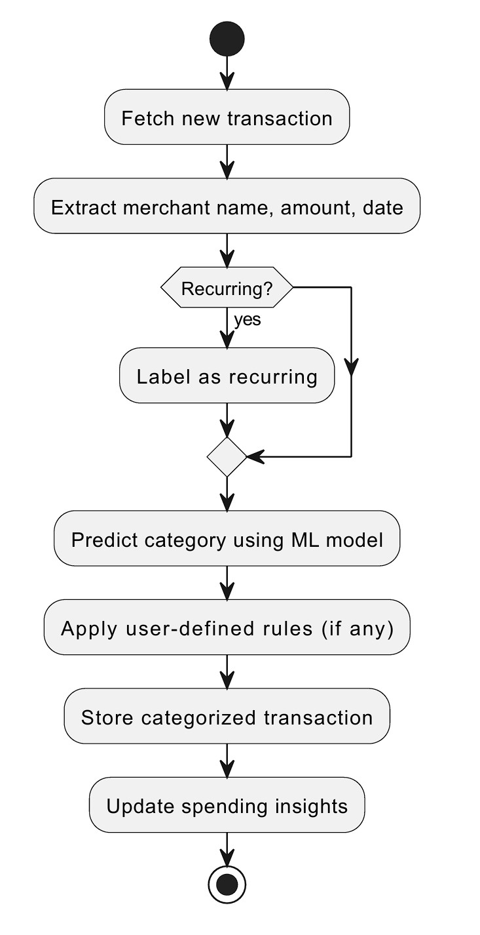

Fig 02: Activity Diagram
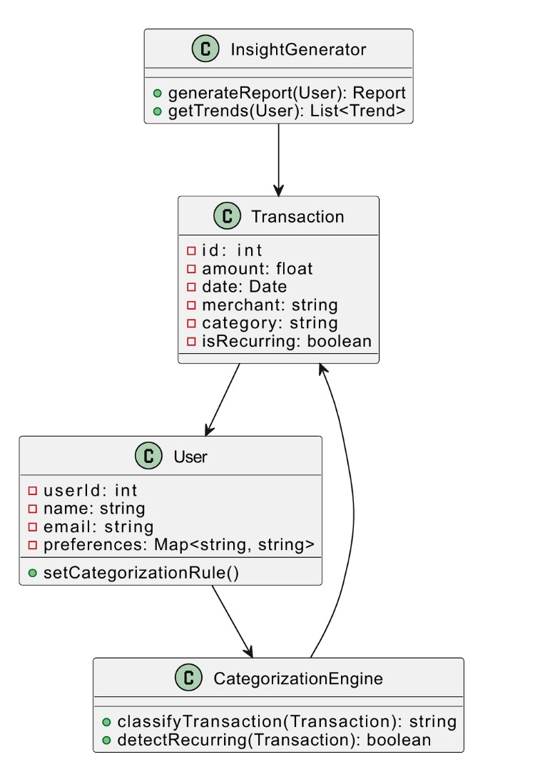

Fig 03: Class Diagram
4.USER STORY TABLE
ID | As a… | I want to… | So that I can…
US1 | Registered user | securely log in using multi-factor authentication | protect my banking account and personal financial data
US2 | New user | register using my email and phone number | start using the smart expense features in my banking app
US3 | Account holder | see my transactions automatically categorized | quickly understand where my money is being spent
US4 | Account holder | change the category of a transaction | keep my expense records accurate and personalized
US5 | Budget-conscious user | set monthly budgets for different expense categories | control my spending and avoid overspending
US6 | Budget-conscious user | receive alerts when my spending reaches a certain percentage of my budget | adjust my spending before I exceed my limits
US7 | Analytical user | view charts and graphs of my spending over time | identify trends and make better financial decisions
US8 | Analytical user | export my spending data as PDF or CSV | save or share my financial records outside the app
US9 | Security-focused user | know that my data is encrypted and standard-compliant | trust that my financial information  is safe and protected

5. Requirement traceability matrix
Req ID | Requirement description (short) | Type | Related User Stories
FR1.1 | User registration with email and phone verification | FR | US2
FR1.2 | Multi-factor authentication for secure login | FR | US1, US9
FR1.3 | Automatic transaction categorization by merchant and amount | FR | US3
FR1.4 | User can modify transaction categories | FR | US4
FR1.5 | ML model improves categorization over time | FR | US3, US4
FR1.6 | Users can set monthly spending limits per category | FR | US5
FR1.7 | System notifies users when spending exceeds budget threshold | FR | US6
FR1.8 | System displays spending trends with charts and graphs | FR | US7
FR1.9 | Users can export reports as PDF or CSV | FR | US8
FR1.10 | Transaction data encrypted and audit logs maintained | FR | US1, US9
NFR2.1 | System processes high transaction volume with low latency | NFR | US3, US7
NFR2.2 | Dashboard loads within acceptable response time | NFR | US3, US7
NFR2.3 | UI is easy to use and allows quick setup of categories | NFR | US2, US3, US4
NFR2.4 | System maintains high availability and daily backups | NFR | US1–US9
NFR2.5 | System scales to handle millions of transactions per day | NFR | US3, US7
NFR2.6 | Modular architecture and automated testing for maintainability | NFR | US1–US9
NFR2.7 | Compliance with PCI-DSS and GDPR for data protection | NFR | US1, US9

5.1. Functional Requirements
5.1.1 User Authentication & Security
1.1.1 The system shall allow users to register using email and phone verification.
1.1.2 The system shall support multi-factor authentication for secure login.
1.1.3 If the login attempts exceed three times, the account shall be temporarily blocked.
1.1.4 Users shall have the ability to reset passwords through OTP verification.
Priority Level: High
Precondition: The user must provide valid login credentials.
5.1.2 Automatic Expense Categorization
1.2.1 The system shall automatically classify transactions based on merchant and amount.
1.2.2 Users shall be able to adjust and modify categories if needed.
1.2.3 Machine Learning algorithms shall improve categorization accuracy over time.
Priority Level: High

5.1.3 Budget Tracking & Alerts
1.3.1 Users shall be able to set monthly spending limits per category.
1.3.2 The system shall notify users when they exceed 80% of their budget.
1.3.3 Budget recommendations shall be generated based on past spending patterns.
Priority Level: Medium

5.1.4 Spending Insights & Reports
1.4.1 The system shall display spending trends using charts and graphs.
1.4.2 Users shall be able to export spending reports in PDF or CSV format.
1.4.3 AI-powered insights shall provide financial tips for better money management.
Priority Level: Medium
1.5 Data Security & Compliance
1.5.1 The system shall encrypt transaction data using AES-256 encryption.
1.5.2 Financial data shall comply with PCI-DSS security standards.
1.5.3 The system shall provide audit logs for user activities.
Priority Level: High

5.2. Non-Functional Requirements
5.2.1 Performance
2.1.1 The system shall process up to 100,000 transactions per second without lag.
2.1.2 The dashboard shall load within 2 seconds under normal conditions.
5.2.2 Usability
2.2.1 First-time users shall be able to set up their expense categories within 5 minutes.
2.2.2 The UI shall provide an intuitive interface with simple navigation.
5.2.3 Security
2.3.1 User login shall require multi-factor authentication.
2.3.2 All financial data shall be stored in an encrypted database.
5.2.4 Reliability
2.4.1 The system shall maintain a 99.9% uptime guarantee.
2.4.2 Automatic backups shall be created daily to prevent data loss.
5.2.5 Scalability
2.5.1 The system shall be capable of handling millions of transactions per day.
2.5.2 Cloud auto-scaling shall be implemented to handle peak loads.
2.6.1 The system shall have modular architecture for easy updates.
2.6.2 Automated testing shall be performed before every software release.
UI / Wireframe Design using Figma

SOFTWARE TESTING
1.Introduction
This test plan outlines the testing strategy for the financial application that includes user authentication, expense tracking, categorization, budgeting, and reporting. It ensures the system is functionally and non-functionally compliant with the SRS.
2.Objectives
- Ensure all functional and non-functional requirements are met
- Verify system performance, security, and usability
- Detect and resolve any software defects prior to release
3.Test Items
- Registration and login modules
- Transaction ingestion and categorization
- Budget management and alerts
- Reports and insights
- Data encryption and audit logging
4.Features to be Tested
- Email/Phone-based registration
- Multi-factor authentication
- Expense categorization via ML
- Budget limit notifications
- Spending charts and exports
- Data security and audit logging
5.Features Not to be Tested
- Internal architecture (covered in integration/system testing)
- Third-party bank APIs (mocked during testing)
6.Test Strategy
- Functional Testing: For verifying each requirement
- Integration Testing: Ensuring modules work together (e.g., budget + alerts)
- System Testing: End-to-end flow testing (register → login → transact → categorize)
- Regression Testing: After every build update
- Security Testing: OTP, MFA, encryption, access control
- Performance Testing: Transactions per second, dashboard load time
- Usability Testing: For intuitive UI and quick category setup

UI / Wireframe Design using Figma

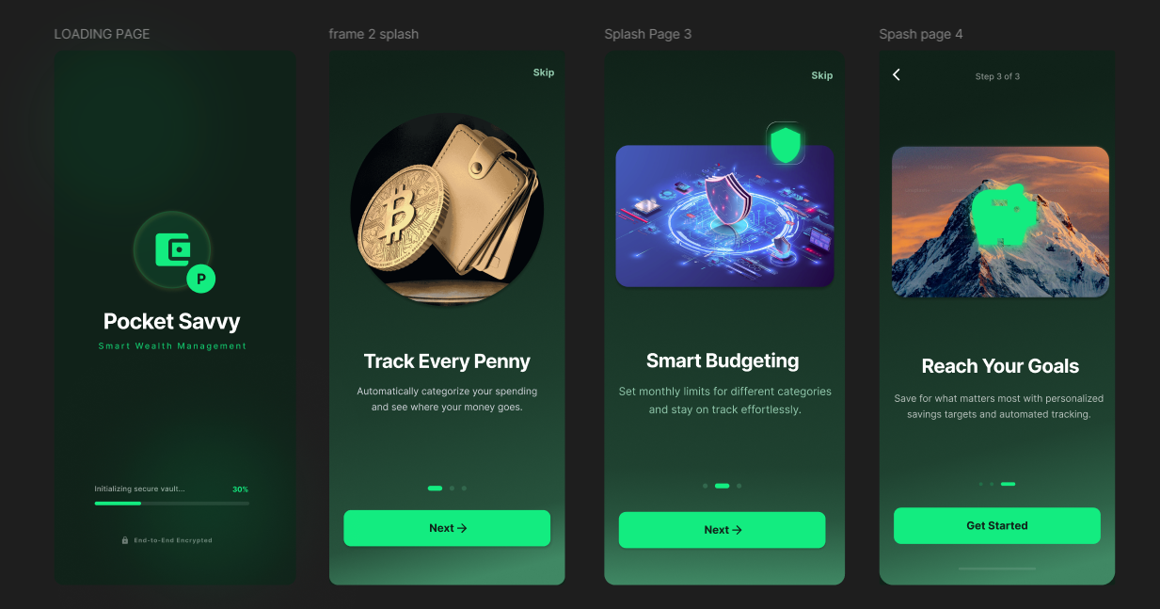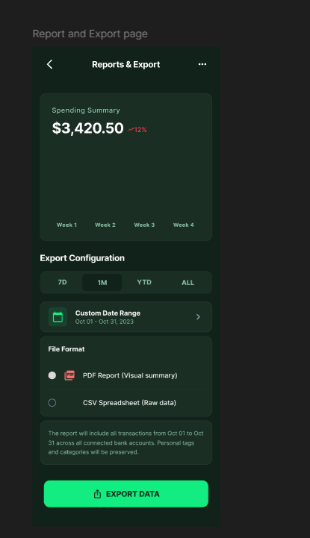

Designed By Name: MD. AHOSAN HABIB UTSHO

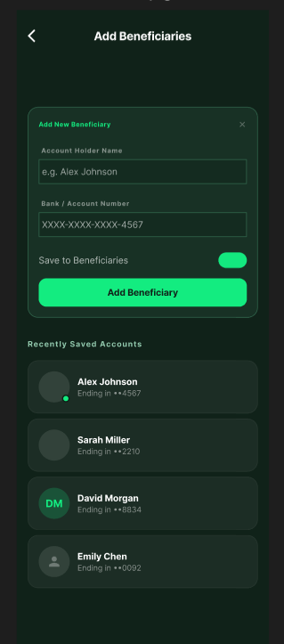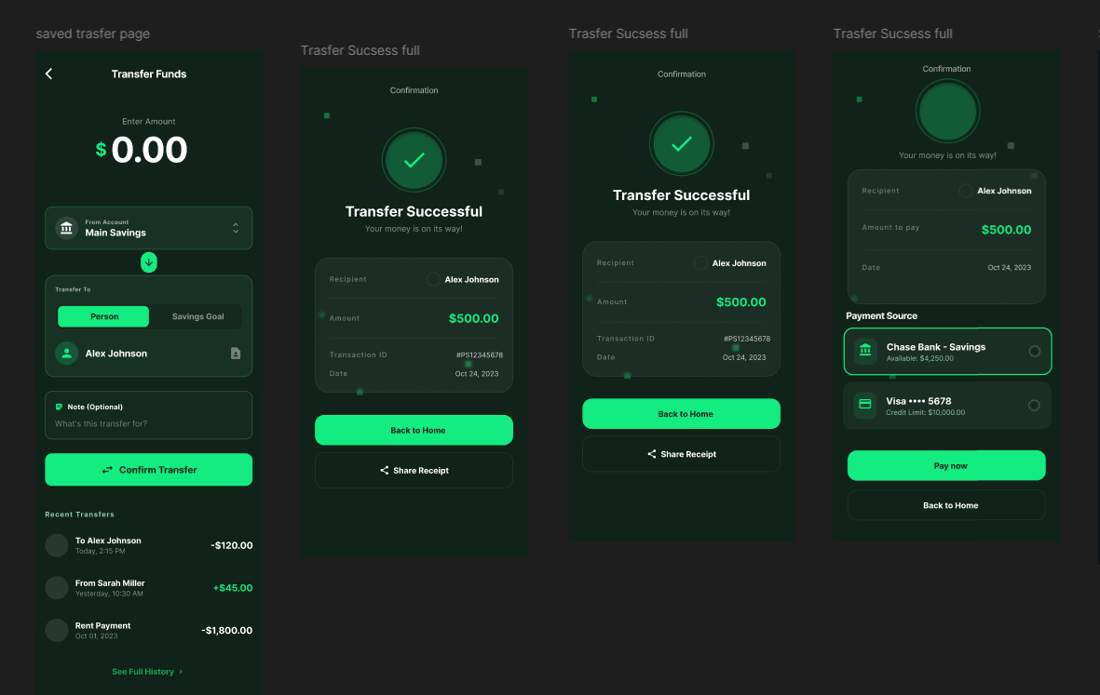

Designed By Name: MD.ASIB IQBAL HOSSIAN

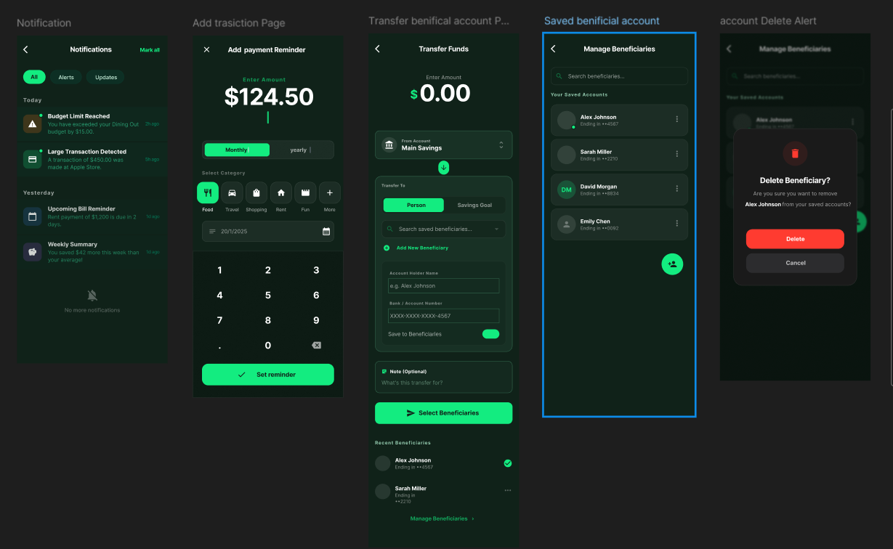

Designed By Name: MD.AFIQUL ISLAM

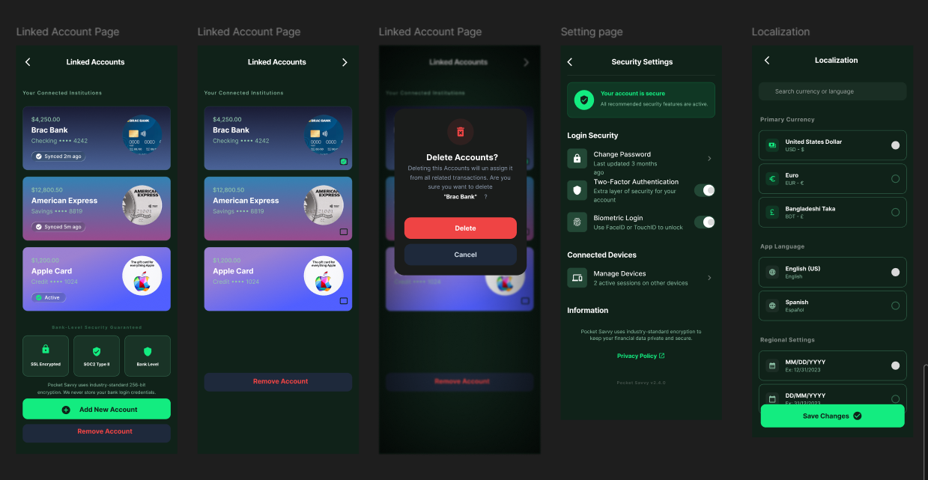
Designed By Name: ALI AHMED NAEEM

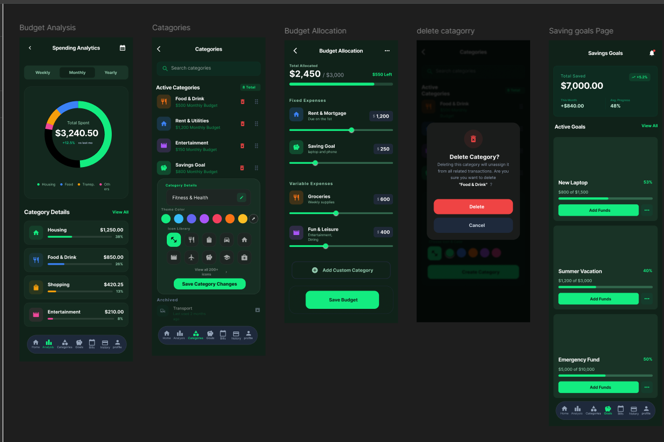

Designed by Name: MD JUBAIR IMTIAJ

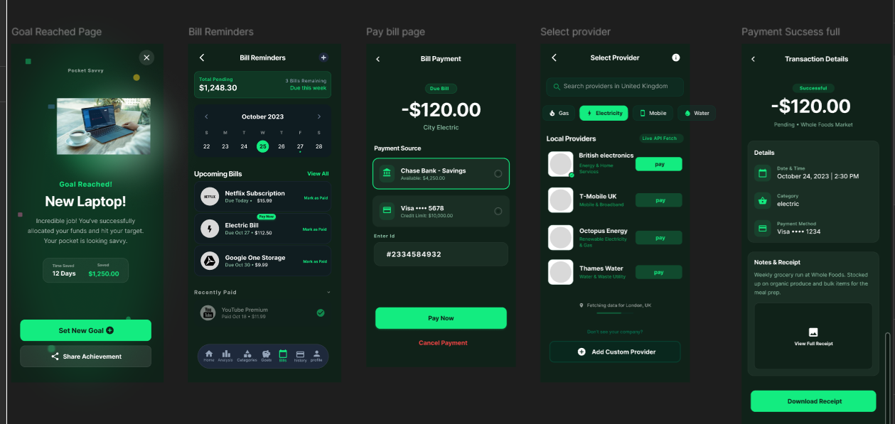
Designed by Name: MD JUBAIR IMTIAJ

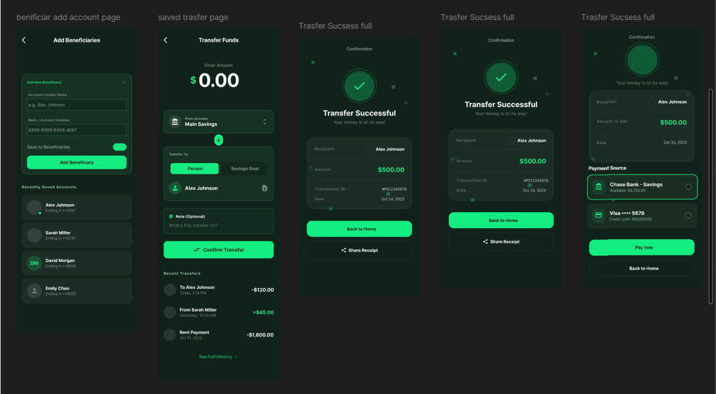

Designed by Name: MD JUBAIR IMTIAJ

GIT WORKFLOW

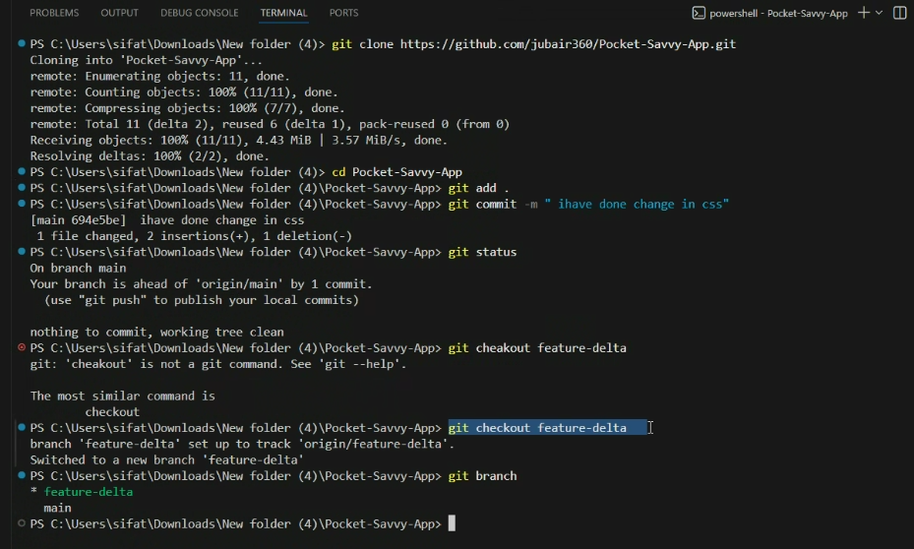

SOFTWARE TESTING

Project Name: Pocket Savvy |  |  | Test Designed By: MD. AFIQUL ISLAM
Test Case ID: 01 |  |  | Test Designed date: 11/05/2025
Test Priority (Low, Medium, High): Medium |  |  | Test Executed By: MD. AFIQUL ISLAM
Module Name: Registration |  |  | Test Execution Date: 19-1-2026
Test Title: Verify user registration with valid email and phone number

Description: Test application registration page

Precondition (If any): User must provide a valid and unique email and phone number

Test Steps | Test Data | Expected Results |  | Actual Results | Status (Pass/Fail)
- Go to the application  - Navigate to registration or sign up page  - Enter valid email  - Enter valid phone number  - Enter other required details  - Click register or sign up | Email:  user@example.com Phone: 9999999999 Password:  Test@123 | User should be successfully  registered and  redirected to login/dashboard |  | As expected | pass
Post Condition: User is registered in the system. Confirmation email/SMS may be sent and user data is stored in the database.

Project Name: Pocket Savvy |  |  | Test Designed By: MD. AFIQUL ISLAM
Test Case ID: 02 |  |  | Test Designed date: 11/05/2025
Test Priority (Low, Medium, High): Medium |  |  | Test Executed By: MD. AFIQUL ISLAM
Module Name: Registration |  |  | Test Execution Date: 19-1-2026
Test Title: Validate email verification during user registration

Description: Test email verification process after user submits registration form
Precondition (If any): User must enter a valid and unique email address during registration

Test Steps | Test Data | Expected Results |  | Actual Results | Status (Pass/Fail)
- Go to the application  - Navigate to registration page  - Enter valid email  - Fill out other registration fields  - Click register  - Check email inbox  - Click on verification link | Email:  user@example.com Phone: 9999999999 Password:  Test@123 | Verification email should be received  and clicking the link should verify the email and activate the  account |  | As expected | pass
Post Condition: User’s email is verified and the account is marked as active in the database. User can now log in successfully.

Project Name: Pocket Savvy |  |  | Test Designed By: MD. AFIQUL ISLAM
Test Case ID: 03 |  |  | Test Designed date: 11/05/2025
Test Priority (Low, Medium, High): Medium |  |  | Test Executed By: MD. AFIQUL ISLAM
Module Name: Registration |  |  | Test Execution Date: 19-1-2026
Test Title: Validate phone number verification via OTP during registration

Description: Test OTP verification step during user registration
Precondition (If any): User must enter a valid and unique phone number during registration

Test Steps | Test Data | Expected Results |  | Actual Results | Status (Pass/Fail)
- Go to the application  - Navigate to registration page  - Enter valid phone number  - Click “Send OTP”  - Enter received OTP  - Submit registration | Phone: 9999999999 OTP: 123456 | OTP should be received and user should be able to verify phone number and complete registration |  | As expected | pass
Post Condition: Phone number is verified, and account is registered and activated.

Project Name: Pocket Savvy |  |  | Test Designed By: MD. AFIQUL ISLAM
Test Case ID: 04 |  |  | Test Designed date: 11/05/2025
Test Priority (Low, Medium, High): High |  |  | Test Executed By: MD. AFIQUL ISLAM
Module Name: Authentication |  |  | Test Execution Date: 19-01-2026
Test Title: Test multi-factor authentication setup during login
Description: Test enabling and configuring MFA (e.g., via OTP/email/app) after first login
Precondition (If any): User has a valid account and login credentials
Test Steps | Test Data | Expected Results |  | Actual Results | Status (Pass/Fail)
- Login with valid credentials  - Navigate to security settings  - Enable MFA  - Choose verification method  (OTP/App)  - Save settings | Username:  user@example.com Password:  Test@123 | MFA should be enabled and preferred method should be stored |  | As expected | pass
Post Condition: MFA is successfully configured and linked to the user account.

Project Name: Pocket Savvy |  |  | Test Designed By: MD. AFIQUL ISLAM
Test Case ID: 05 |  |  | Test Designed date: 11/05/2025
Test Priority (Low, Medium, High): High |  |  | Test Executed By: MD. AFIQUL ISLAM
Module Name: Login |  |  | Test Execution Date: 19-01-2026
Test Title: Test successful login with correct credentials and MFA
Description: Verify login process with valid credentials and successful MFA
Precondition (If any): User has a valid account and login credentials
Test Steps | Test Data | Expected Results |  | Actual Results | Status (Pass/Fail)
- Enter valid username and password  - Receive MFA code  - Enter MFA code  - Login | Username:  user@example.com Password:  Test@123  OTP: 654321 | User should be authenticated and logged into their dashboard |  | As expected | pass
Post Condition: User is successfully logged in with multi-factor authentication.

Project Name: Pocket Savvy |  |  | Test Designed By: MD. AFIQUL ISLAM
Test Case ID: 06 |  |  | Test Designed date: 11/05/2025
Test Priority (Low, Medium, High): High |  |  | Test Executed By: MD. AFIQUL ISLAM
Module Name: Login |  |  | Test Execution Date: 19-01-2026
Test Title: Test account lockout after 3 failed login attempts
Description: Ensure system locks account after three consecutive incorrect login attempts
Precondition (If any): User must exist in system with valid credentials
Test Steps | Test Data | Expected Results |  | Actual Results | Status (Pass/Fail)
- Attempt login with wrong password (3 times)  - Try correct login on 4th attempt | Username:  user@example.com Passwords: wrong1, wrong2, wrong3  Correct password: Test@123 | Account should be locked after 3 failed attempts; login should be blocked even with correct credentials |  | As expected, | pass
Post Condition: Account is locked and cannot be accessed until unlocked via admin or recovery process.

Project Name: Pocket Savvy |  |  | Test Designed By: MD JUBAIR IMTIAJ
Test Case ID: 07 |  |  | Test Designed date: 11/05/2025
Test Priority (Low, Medium, High): High |  |  | Test Executed By: MD JUBAIR IMTIAJ
Module Name: Login |  |  | Test Execution Date: 19-01-2026
Test Title: Verify account unlock after timeout or admin action
Description: Ensure account is unlocked after a specific timeout or manual admin intervention
Precondition (If any): Account must be locked due to failed login attempts
Test Steps | Test Data | Expected Results |  | Actual Results | Status (Pass/Fail)
- Lock account with 3 failed logins  - Wait for lockout timeout OR request admin to unlock  - Try logging in with correct credentials | Username:  user@example.com Password:  Test@123 | User should be able to log in once account is unlocked by timeout or admin |  | As expected | pass
Post Condition: User can access the account again successfully.

Project Name: Pocket Savvy |  |  | Test Designed By: MD JUBAIR IMTIAJ
Test Case ID: 08 |  |  | Test Designed date: 11/05/2025
Test Priority (Low, Medium, High): High |  |  | Test Executed By: MD JUBAIR IMTIAJ
Module Name: Password Recovery |  |  | Test Execution Date: 19-01-2026
Test Title: Test password reset via OTP verification
Description: Verify user can reset password by entering correct OTP received on phone/email
Precondition (If any): User must have a registered email/phone number
Test Steps | Test Data | Expected Results |  | Actual Results | Status (Pass/Fail)
- Go to forgot password page  - Enter email/phone number  - Receive OTP  - Enter correct OTP  - Enter new password and confirm | Email:  user@example.com OTP: 123456 New Password:  NewPass@123 | OTP is verified and password is successfully reset |  | As expected | pass
Post Condition: User's password is updated in the system and can be used for login.

Project Name: Pocket Savvy |  |  | Test Designed By MD JUBAIR IMTIAJ
Test Case ID: 09 |  |  | Test Designed date: 11/05/2025
Test Priority (Low, Medium, High): High |  |  | Test Executed By: MD JUBAIR IMTIAJ
Module Name: Password Recovery |  |  | Test Execution Date: 19-01-2026
Test Title: Verify invalid OTP blocks password reset
Description: Ensure password cannot be reset with incorrect OTP
Precondition (If any): User has initiated password reset and received OTP
Test Steps | Test Data | Expected Results |  | Actual Results | Status (Pass/Fail)
- Go to forgot password page  - Enter email/phone number  - Enter incorrect OTP  - Attempt to proceed | Email:  user@example.com  OTP: 999999  (invalid) | System should block password reset and show error |  | As expected | pass
Post Condition: Password remains unchanged, and user must request a new OTP.

Project Name: Pocket Savvy |  |  | Test Designed By: MD JUBAIR IMTIAJ
Test Case ID: 10 |  |  | Test Designed date: 11/05/2025
Test Priority (Low, Medium, High): Medium |  |  | Test Executed By: MD JUBAIR IMTIAJ
Module Name: Login |  |  | Test Execution Date: 19-01-2026
Test Title: Check login functionality post-password reset
Description: Verify user can log in successfully using newly reset password
Precondition (If any): Password must have been recently reset via valid process
Test Steps | Test Data | Expected Results |  | Actual Results | Status (Pass/Fail)
- Go to login page  - Enter username and new password  - Click login | Username:  user@example.com Password:  NewPass@123 | User should be logged in successfully |  | As expected | pass
Post Condition: User is logged into the system with the new password.

Project Name: Pocket Savvy |  |  | Test Designed By: MD JUBAIR IMTIAJ
Test Case ID: 11 |  |  | Test Designed date: 11/05/2025
Test Priority (Low, Medium, High): Medium |  |  | Test Executed By: MD JUBAIR IMTIAJ
Module Name: Transaction Categorization |  |  | Test Execution Date: 19-01-2026
Test Title: Validate automatic classification of transaction based on merchant name
Description: Ensure transactions are categorized automatically based on recognized merchant names
Precondition (If any): System must have predefined merchant-category mappings
Test Steps | Test Data | Expected Results |  | Actual Results | Status (Pass/Fail)
- Make a transaction with a known merchant  - View transaction category | Merchant:  Starbucks  Amount: 5.00 | Category should be auto-set to “Food” |  | As expected | pass
Post Condition: Transaction is saved with the appropriate category based on merchant name.

Project Name: Pocket Savvy |  |  | Test Designed By: MD JUBAIR IMTIAJ
Test Case ID: 12 |  |  | Test Designed date: 11/05/2025
Test Priority (Low, Medium, High): Medium |  |  | Test Executed By: MD JUBAIR IMTIAJ
Module Name: Transaction Categorization |  |  | Test Execution Date: 19-01-2026
Test Title: Validate automatic classification based on transaction amount
Description: Ensure system classifies certain transactions based on amount range when merchant data is unavailable
Precondition (If any): Merchant name is unknown or not present in the database
Test Steps | Test Data | Expected Results |  | Actual Results | Status (Pass/Fail)
- Perform a transaction with an unknown merchant  - Check the auto-assigned category. | Merchant: XYZ  Store  Amount: 1200.00 | Category should be assigned based on amount (e.g.,  “Electronics” or “High Value”) |  | As expected | pass
Post Condition: Transaction is auto-categorized using amount-based logic.

Project Name: Pocket Savvy |  |  | Test Designed By: Md Jubair Imtiaj
Test Case ID: 13 |  |  | Test Designed date: 11/05/2025
Test Priority (Low, Medium, High): Medium |  |  | Test Executed By: Md Jubair Imtiaj
Module Name: Transaction Management |  |  | Test Execution Date: 19-02-2026
Test Title: Test user modification of auto-assigned expense category
Description: Allow user to override and update the auto-assigned category
Precondition (If any): Transaction should have an existing category assigned automatically
Test Steps | Test Data | Expected Results |  | Actual Results | Status (Pass/Fail)
1. Open transaction details 2. Edit category from autoassigned to user-chosen category 3. Save changes. | Original Category: Shopping Updated to:  Medical | Category should update to “Medical” after save |  | As expected | pass
Post Condition: Modified category is saved and reflected in transaction details.

Project Name: Pocket Savvy |  |  | Test Designed By: Md Jubair Imtiaj
Test Case ID: 14 |  |  | Test Designed date: 11/05/2025
Test Priority (Low, Medium, High): Medium |  |  | Test Executed By: Md Jubair Imtiaj
Module Name: Transaction Management |  |  | Test Execution Date: 19-01-2026
Test Title: Verify updated category persists after user modification
Description: Ensure modified category is not reverted to auto-assigned one upon reload or sync
Precondition (If any): Category must have been updated manually by the user
Test Steps | Test Data | Expected Results |  | Actual Results | Status (Pass/Fail)
- Modify transaction category  - Refresh the page or sync app  - Check category again | Updated Category: Medical | Updated category should remain as  “Medical” |  | As expected | pass
Post Condition: Updated category is retained and not overwritten by the system.

Project Name: Pocket Savvy |  |  | Test Designed By: MD.ASIB IQBAL HOSSIAN
Test Case ID: 15 |  |  | Test Designed date: 11/05/2025
Test Priority (Low, Medium, High): Medium |  |  | Test Executed By: : MD.ASIB IQBAL HOSSIAN
Module Name: Machine Learning Engine |  |  | Test Execution Date: 19-01-2026
Test Title: Check ML algorithm adapts to user-adjusted categories over time
Description: Validate whether the ML model learns from repeated manual changes by the user
Precondition (If any): User must have updated multiple similar transactions consistently
Test Steps | Test Data | Expected Results |  | Actual Results | Status (Pass/Fail)
- Manually change category for  5+ similar transactions  - Add a new similar transaction 3. Check if new transaction is auto-classified as per learned pattern | Merchant: ABC  Cafe  Previously changed to: Groceries | System should autoclassify new ABC  Cafe transaction as  Groceries |  | As expected | pass
Post Condition: ML model updates classification logic based on user input behavior.

Project Name: Pocket Savvy |  |  | Test Designed By: : MD.ASIB IQBAL HOSSIAN
Test Case ID: 16 |  |  | Test Designed date: 11/05/2025
Test Priority (Low, Medium, High): Medium |  |  | Test Executed By: : MD.ASIB IQBAL HOSSIAN
Module Name: Budget Management |  |  | Test Execution Date: 19-01-2026
Test Title: Test setting of monthly budget limit per category
Description: Confirm system correctly allocates transactions and aggregates expenses per budget category
Precondition (If any): Monthly budget must be set for at least one category
Test Steps | Test Data | Expected Results |  | Actual Results | Status (Pass/Fail)
1. Add expenses under a budgeted category 2. View expense summary | Category:  Transport  Transactions: 1200  + 800 | Total expense for Transport = 2000 displayed |  | As expected | pass
Post Condition: System continuously updates expense tally per category.
Project Name: Pocket Savvy |  |  | Test Designed By: : MD.ASIB IQBAL HOSSIAN
Test Case ID: 17 |  |  | Test Designed date: 11/05/2025
Test Priority (Low, Medium, High): Medium |  |  | Test Executed By: : MD.ASIB IQBAL HOSSIAN
Module Name: Notifications |  |  | Test Execution Date: 19-01-2026
Test Title: Verify alert notification when 80% budget usage is reached
Description: Ensure system sends notification when a user reaches 80% of their monthly category budget
Precondition (If any): Budget limit is set; user has opted in for notifications
Test Steps | Test Data | Expected Results |  | Actual Results | Status (Pass/Fail)
- Spend up to 80% of category limit  - Observe if alert is triggered | Preferred Channel:  SMS | Alert should be delivered via SMS |  | As expected | pass
Post Condition: User receives timely alert before exceeding the budget.

Project Name: Pocket Savvy |  |  | Test Designed By: : MD.ASIB IQBAL HOSSIAN
Test Case ID: 18 |  |  | Test Designed date: 11/05/2025
Test Priority (Low, Medium, High): Medium |  |  | Test Executed By: : MD.ASIB IQBAL HOSSIAN
Module Name: Notification Preferences |  |  | Test Execution Date: 19-01-2026
Test Title: Test alert delivery through preferred channel (email/SMS/push)
Description: Validate user receives alerts via selected communication method
Precondition (If any): User must configure preferred alert channel in profile settings
Test Steps | Test Data | Expected Results |  | Actual Results | Status (Pass/Fail)
- Set preferred alert channel  - Trigger a budget alert (e.g.,  80% usage)  - Check channel for alert | Preferred Channel:  SMS | Alert should be delivered via SMS |  | As expected | pass
Post Condition: System sends alerts using the selected communication method.

Project Name: Pocket Savvy |  |  | Test Designed By: : MD.ASIB IQBAL HOSSIAN
Test Case ID: 19 |  |  | Test Designed date: 11/05/2025
Test Priority (Low, Medium, High): Low |  |  | Test Executed By: : MD.ASIB IQBAL HOSSIAN
Module Name: Budget Insights |  |  | Test Execution Date: 19-01-2026a
Test Title: Check system generates budget recommendations based on historical data
Description: Verify the system analyzes past spending trends to suggest monthly budgets
Precondition (If any): At least 3 months of transaction history available
Test Steps | Test Data | Expected Results |  | Actual Results | Status (Pass/Fail)
- Navigate to Insights or Budget  Recommendation section  - View suggestions | Category:  Groceries  Avg Monthly  Spend: 4500 | System recommends a monthly budget close to 4500 |  | As expected | pass
Post Condition: Recommendations help users plan budgets more accurately.

Project Name: Pocket Savvy |  |  | Test Designed By: : MD.ASIB IQBAL HOSSIAN
Test Case ID: 20 |  |  | Test Designed date: 11/05/2025
Test Priority (Low, Medium, High): Low |  |  | Test Executed By: : MD.ASIB IQBAL HOSSIAN
Module Name: Budget Insights |  |  | Test Execution Date: 19-01-2026
Test Title: Check system generates budget recommendations based on historical data
Description: Verify the system analyzes past spending trends to suggest monthly budgets
Precondition (If any): At least 3 months of transaction history available
Test Steps | Test Data | Expected Results |  | Actual Results | Status (Pass/Fail)
- Navigate to Insights or Budget  Recommendation section  - View suggestions | Category:  Groceries  Avg Monthly  Spend: 4500 | System recommends a monthly budget close to 4500 |  | As expected | pass
Post Condition: Recommendations help users plan budgets more accurately.

Project Name: Pocket Savvy |  |  | Test Designed By: AHASAN HABIB UTSHO
Test Case ID: 21 |  |  | Test Designed date: 11/05/2025
Test Priority (Low, Medium, High): Medium |  |  | Test Executed By: AHASAN HABIB UTSHO
Module Name: Analytics Dashboard |  |  | Test Execution Date: 19-01-2026
Test Title: Verify display of spending trends in pie chart format
Description: Ensure the dashboard displays category-wise spending as a pie chart
Precondition (If any): User must have transactions in multiple categories
Test Steps | Test Data | Expected Results |  | Actual Results | Status (Pass/Fail)
- Log in to dashboard  - Navigate to spending trends section  - View pie chart | Categories: Food, Travel, Shopping | Pie chart displays percentage of spend per category |  | As expected | pass
Post Condition: Visual representation of spending across categories is available.

Project Name: Pocket Savvy |  |  | Test Designed By: AHASAN HABIB UTSHO
Test Case ID: 22 |  |  | Test Designed date: 11/05/2025
Test Priority (Low, Medium, High): Medium |  |  | Test Executed By: AHASAN HABIB UTSHO
Module Name: Analytics Dashboard |  |  | Test Execution Date: 19-01-2026
Test Title: Verify display of monthly trends in bar graph format
Description: Confirm the system displays monthly spending summaries in a bar graph
Precondition (If any): User must have transaction data across multiple months
Test Steps | Test Data | Expected Results |  | Actual Results | Status (Pass/Fail)
- Log in to dashboard  - Access monthly trends  - View bar graph | Monthly Spend:  Jan - 4000, Feb - 6000, Mar - 5500 | Bar chart shows values for each month with proper labels |  | As expected | pass
Post Condition: Graphical comparison of monthly spending is accessible.
Project Name: Pocket Savvy |  |  | Test Designed By: AHASAN HABIB UTSHO
Test Case ID: 23 |  |  | Test Designed date: 11/05/2025
Test Priority (Low, Medium, High): Medium |  |  | Test Executed By: AHASAN HABIB UTSHO
Module Name: Reports |  |  | Test Execution Date: 19-01-2026
Test Title: Test export of spending report as CSV
Description: Ensure report data is correctly exported in CSV format for external analysis
Precondition (If any): User has transactions to include in report
Test Steps | Test Data | Expected Results |  | Actual Results | Status (Pass/Fail)
- Go to reports  - Set filters/date range  - Click “Export as CSV” | Date Range: Feb 1 - Feb 28 | CSV file is downloaded with structured data |  | As expected | pass
Post Condition: CSV file can be opened in spreadsheet software for further analysis.

Project Name: Pocket Savvy |  |  | Test Designed By: AHASAN HABIB UTSHO
Test Case ID: 24 |  |  | Test Designed date: 11/05/2025
Test Priority (Low, Medium, High): High |  |  | Test Executed By: AHASAN HABIB UTSHO
Module Name: Financial Insights |  |  | Test Execution Date: 19-01-2026
Test Title: Validate presence of AI-generated financial tips based on spending behavior
Description: Confirm that AI analyzes user habits and displays personalized financial advice
Precondition (If any): User must have at least 2 months of transaction history
Test Steps | Test Data | Expected Results |  | Actual Results | Status (Pass/Fail)
- Open Financial Insights section  - Check suggested tips | User spending: Excess in Dining category | Tip: “You’ve spent 30% more than average on dining. Consider meal planning.” |  | As expected | pass
Post Condition: Personalized, actionable advice is shown based on behavior trends.
Project Name: Pocket Savvy |  |  | Test Designed By: AHASAN HABIB UTSHO
Test Case ID: 25 |  |  | Test Designed date: 11/05/2025
Test Priority (Low, Medium, High): Medium |  |  | Test Executed By: AHASAN HABIB UTSHO
Module Name: Reports |  |  | Test Execution Date: 19-01-2026
Test Title: Test export of spending report as PDF
Description: Validate the ability to generate and download a spending report in PDF format
Precondition (If any): User must have spending data to generate a report
Test Steps | Test Data | Expected Results |  | Actual Results | Status (Pass/Fail)
- Navigate to reports section  - Select date range  - Click “Export as PDF” | Date Range: Jan 1 - Mar 31 | PDF is generated and downloaded with formatted data |  | As expected | pass
Post Condition: User receives a PDF version of the report containing transaction summaries.

Project Name: Pocket Savvy |  |  | Test Designed By: AHASAN HABIB UTSHO
Test Case ID: 26 |  |  | Test Designed date: 11/05/2025
Test Priority (Low, Medium, High):High |  |  | Test Executed By: AHASAN HABIB UTSHO
Module Name: Data Security |  |  | Test Execution Date: 19-01-2026
Test Title: Test encryption of transaction data using AES-256
Description: Ensure all sensitive transaction data is encrypted using AES-256 encryption
Precondition (If any): Transaction data must exist in the system
Test Steps | Test Data | Expected Results |  | Actual Results | Status (Pass/Fail)
1. Submit a transaction 2. Inspect data storage or transmission logs | Transaction: $2500 to ABC Store | Data should appear encrypted using AES256 standard |  | As expected | pass
Post Condition: Encrypted data is stored/transmitted securely and not readable in plaintext.
Project Name: Pocket Savvy |  |  | Test Designed By: AHASAN HABIB UTSHO
Test Case ID: 27 |  |  | Test Designed date: 11/05/2025
Test Priority (Low, Medium, High):High |  |  | Test Executed By: AHASAN HABIB UTSHO
Module Name: Compliance |  |  | Test Execution Date: 19-01-2026
Test Title: Verify data handling adheres to PCI-DSS compliance checklist
Description: Validate that the application follows PCI-DSS guidelines for handling cardholder data
Precondition (If any): System handles card or financial data
Test Steps | Test Data | Expected Results |  | Actual Results | Status (Pass/Fail)
1. Review system architecture 2. Perform audit using PCI-DSS checklist | Checklist items: encryption, access control, logging, etc. | All items on checklist are satisfied |  | As expected | pass
Post Condition: Data handling is compliant with security and privacy standards.

Project Name: Pocket Savvy |  |  | Test Designed By: ALI AHMED NAEEM
Test Case ID: 28 |  |  | Test Designed date: 11/05/2025
Test Priority (Low, Medium, High):High |  |  | Test Executed By: ALI AHMED NAEEM
Module Name: Authentication & Authorization |  |  | Test Execution Date: 19-01-2026
Test Title: Check access to financial data requires secure authentication
Description: Ensure that only authenticated users can access financial data
Precondition (If any): User must have valid login credentials
Test Steps | Test Data | Expected Results |  | Actual Results | Status (Pass/Fail)
- Attempt to access financial data without login  - Attempt with valid login | User:  Unauthenticated /  Authenticated | Unauthenticated: Access Denied Authenticated:  Access Granted |  | As expected | pass
Post Condition: Financial data access is controlled through secure login mechanisms.

Project Name: Pocket Savvy |  |  | Test Designed By : ALI AHMED NAEEM
Test Case ID: 29 |  |  | Test Designed date: 11/05/2025
Test Priority (Low, Medium, High): Medium |  |  | Test Executed By: ALI AHMED NAEEM
Module Name: Logging and Monitoring |  |  | Test Execution Date: 19-01-2026
Test Title: Validate generation of user activity audit logs
Description: Ensure user actions are recorded in audit logs for accountability and traceability
Precondition (If any): User performs an action like login, transaction, or setting update
Test Steps | Test Data | Expected Results |  | Actual Results | Status (Pass/Fail)
- Perform user activity (e.g., login or transfer funds)  - Check audit logs | Action: Login User ID: 12345 | Log entry created for action |  | As expected | pass
Post Condition: Audit logs are generated and available for review.

Project Name: Pocket Savvy |  |  | Test Designed By: ALI AHMED NAEEM
Test Case ID: 30 |  |  | Test Designed date: 11/05/2025
Test Priority (Low, Medium, High): Medium |  |  | Test Executed By: ALI AHMED NAEEM
Module Name: Logging and Monitoring |  |  | Test Execution Date: 19-01-2026
Test Title: Verify audit logs include timestamp, user ID, and action performed
Description: Validate the structure and completeness of audit log entries
Precondition (If any): User action must trigger log generation
Test Steps | Test Data | Expected Results |  | Actual Results | Status (Pass/Fail)
- Trigger an action (e.g., change password)  - Inspect log entry | Action: Password  Change  User ID: 78910 | Log includes:  Timestamp, User ID,  Action |  | As expected | pass
Post Condition: Complete and accurate logs are stored for audit trail.

Project Name: Pocket Savvy |  |  | Test Designed By: ALI AHMED NAEEM
Test Case ID: 31 |  |  | Test Designed date: 11/05/2025
Test Priority (Low, Medium, High): High |  |  | Test Executed By: ALI AHMED NAEEM
Module Name: Banking Integration |  |  | Test Execution Date: 19-01-2026
Test Title: Verify successful bank account connection
Description: Ensure that the user can securely connect their bank account to the app
Precondition (If any): User must have an online bank account and internet access
Test Steps | Test Data | Expected Results |  | Actual Results | Status (Pass/Fail)
1. Navigate to 'Connect Bank' section 2. Select bank  - Enter online banking credentials  - Authorize access | Bank: XYZ Bank Credentials: Valid | Bank account is connected and status is updated to "Linked" |  | As expected | pass
Post Condition: Bank account is securely linked and ready for data sync.

Project Name: Pocket Savvy |  |  | Test Designed By: ALI AHMED NAEEM
Test Case ID: 32 |  |  | Test Designed date: 11/05/2025
Test Priority (Low, Medium, High): High |  |  | Test Executed By: ALI AHMED NAEEM
Module Name: Banking Integration |  |  | Test Execution Date: 19-01-2026
Test Title: Validate automatic retrieval of bank transactions
Description: Check that transaction data is pulled from the connected bank account
Precondition (If any): A bank account must be connected
Test Steps | Test Data | Expected Results |  | Actual Results | Status (Pass/Fail)
- Connect bank account  - Sync transactions  - View transaction list | Transactions from last 7 days | Transactions  (debit/credit) should display with date, amount, and merchant |  | As expected | pass
Post Condition: User can view real-time or recent bank transactions in the app.

Project Name: Pocket Savvy |  |  | Test Designed By: ALI AHMED NAEEM
Test Case ID: 33 |  |  | Test Designed date: 11/05/2025
Test Priority (Low, Medium, High): Medium |  |  | Test Executed By: ALI AHMED NAEEM
Module Name: Banking Integration |  |  | Test Execution Date: 19-01-2026
Test Title: Verify income and expense classification from bank data
Description: Ensure that synced transactions are automatically categorized as income or expenses
Precondition (If any): Bank account should be connected and synced
Test Steps | Test Data | Expected Results |  | Actual Results | Status (Pass/Fail)
- Sync bank account  - View categorized transaction list | Sample Data:  Salary $5,000  Uber $500 | $5,000 tagged as income, $500 as expense under transport |  | As expected | pass
Post Condition: Synced bank transactions are automatically sorted and displayed by category.

CONCLUSION
The Smart Expense Categorization for Mobile Banking Apps project was designed to help users better understand and manage their daily spending in a simple and secure way. By automatically categorizing transactions, providing budget tracking features, and showing spending insights through charts and reports, the system makes financial management easier for users.
Security was a major focus of this project. Features such as multi-factor authentication, data encryption, and audit logs ensure that user information remains protected and trustworthy. The system also allows users to manually adjust categories, making the expense tracking more accurate and personalized over time.
Overall, this project demonstrates how modern technology, including automation and data analysis, can improve user experience in mobile banking. In the future, the system can be enhanced with features like AI-based financial tips, multi-language support, and deeper analytics to make it even more useful for users.

